43.34: (a) rem = rad RBE
200 = x(10)
x = 20 rad
(b) 1 rad deposits 0.010 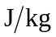, so 20 rad deposit 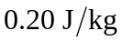. This radiation affects 25 g (0.025 kg) of tissue, so the total energy is
(c) Since RBE = 1 for -rays, so rem = rad. Therefore
20 rad = 20 rem

